S3 task
1.Create an S3 bucket and upload some objects to S3.
• Go to AWS Console → S3
• Click Create bucket
• Enter Bucket Name (must be unique globally)
• Choose a Region
• Keep everything default
• Click Create bucket
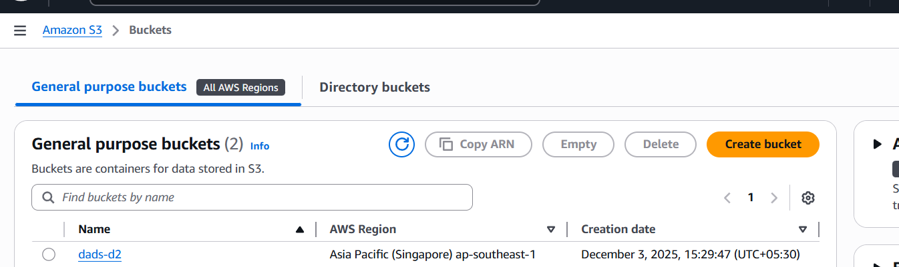
Open your bucket
Click Upload
Click Add files
Choose any file (image, PDF, text, etc.)
Click Upload
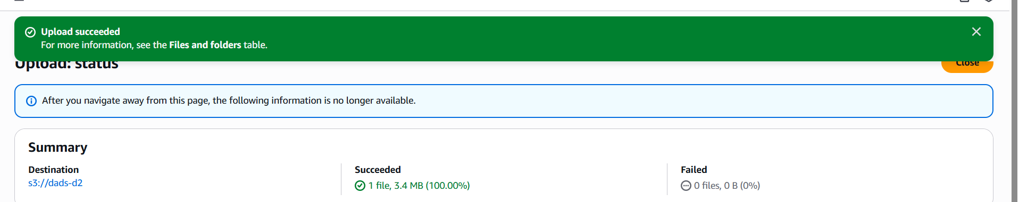
Deploy a static website in the S3 bucket.
Upload the photo
open the image
we have give permission
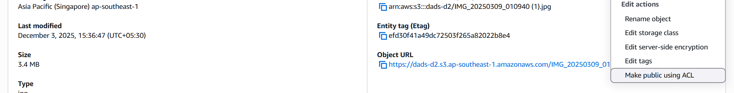
make it as public acl
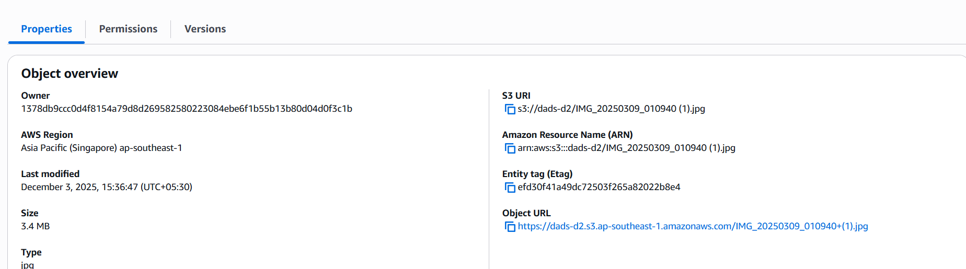
Copy the object url
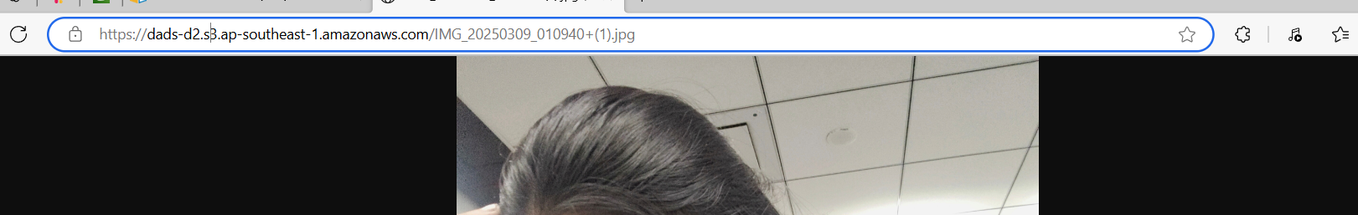

- Enable cross-region replication on S3 buckets.
Go to Buckets → Select bucket → Properties → Versioning → Enable
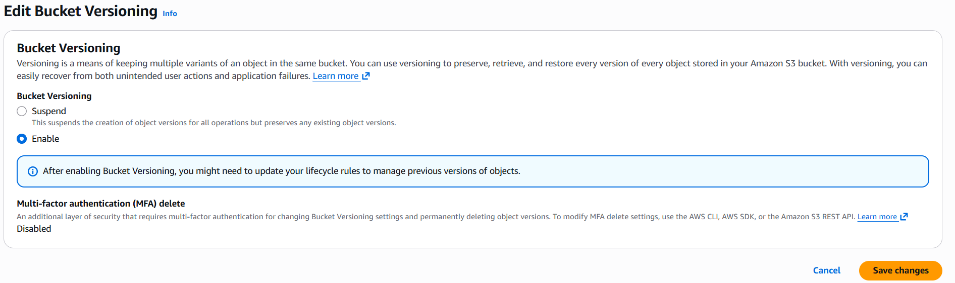
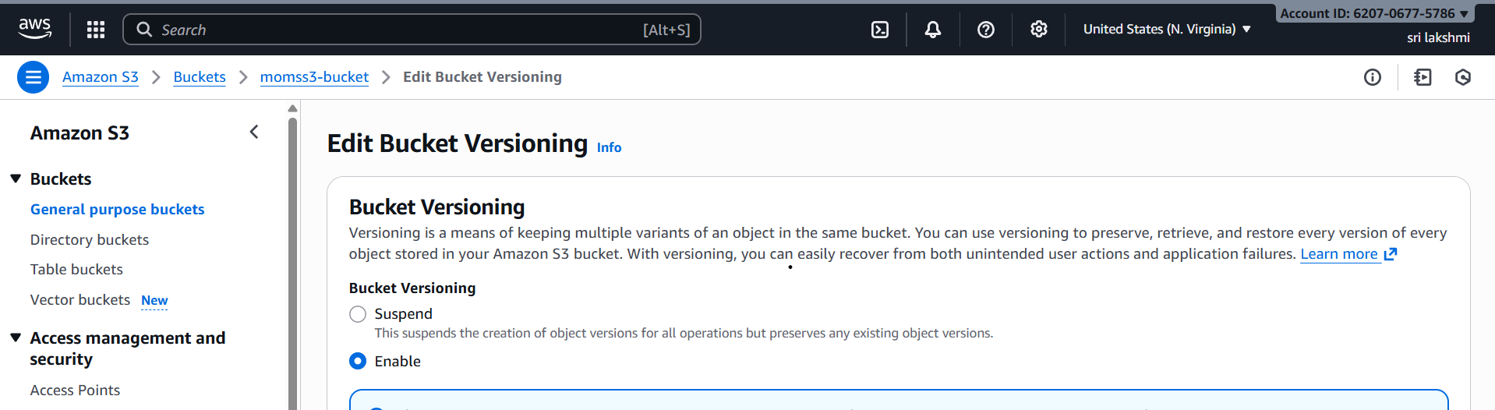
Go to Source Bucket → Management → Replication rules → Create rule
✔ Rule type: Entire bucket
✔ Destination: Select your destination bucket
✔ IAM role: Choose Create new IAM role
✔ Encryption: Select default (no change needed)
✔ Existing objects: Choose Yes/No based on need
Click Save → Replication ill start working.

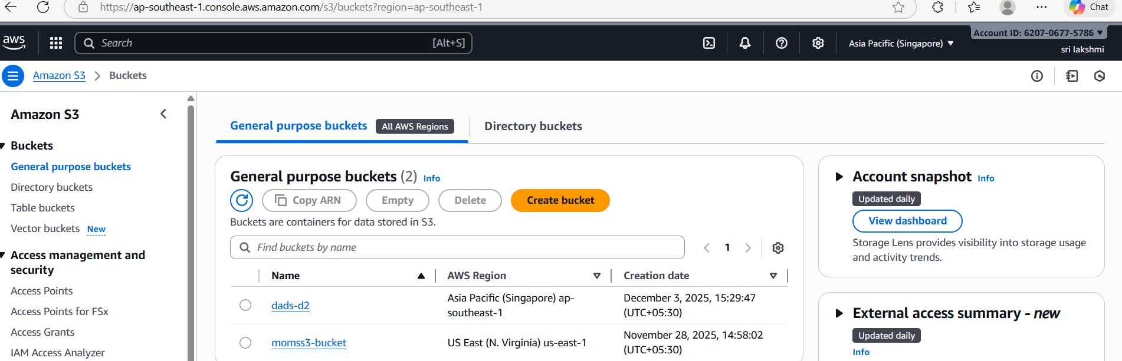

• Upload a file into dads-d2
• Wait 5–30 seconds
• Check momss3-bucket

- Configure a bucket policy so only the Admin user can see the objects of the S3 bucket.
IAM → Users → Admin → Copy User ARN
S3 → Choose your bucket → Permissions → Bucket Policy
Paste the bucket policy (Replace with your values)
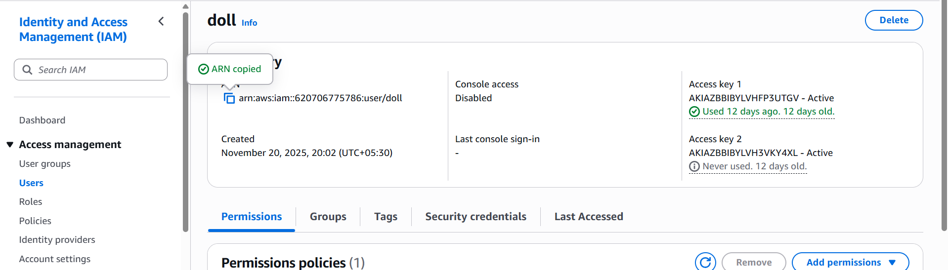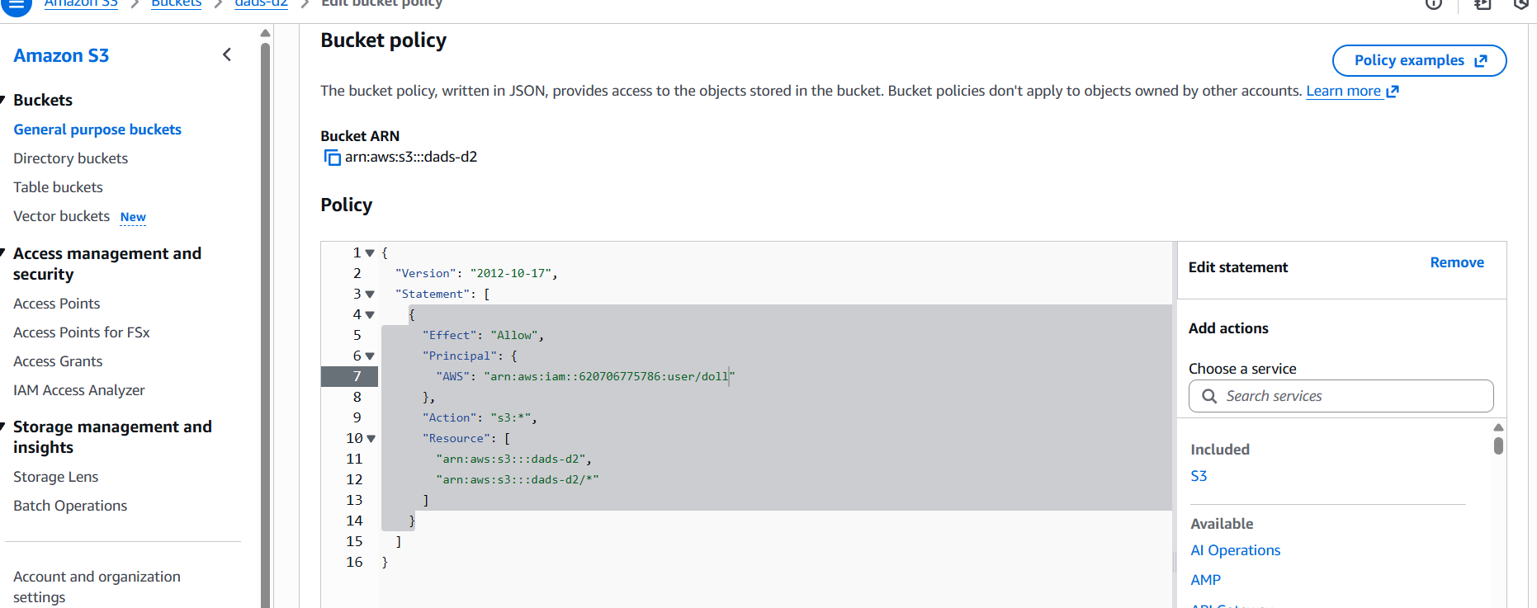
Only Admin user can see, list, upload, download, or delete objects in the bucket.

3.Set up lifecycle policies to automatically transition or delete objects based on specific criteria.
Go to your bucket
- AWS Console → S3 → select your bucket (e.g., dads-d2).
Open Lifecycle rules
- Click Management → Lifecycle rules → Create rule.
Name the rule
- Give it a name (e.g., AutoTransitionDelete).
- Apply to all objects or a specific folder/tag.
Choose actions
- Transition current versions → Move to GLACIER after 30 days.
- Expire current versions → Delete objects after 365 days.
save the rule
- Click Create rule.

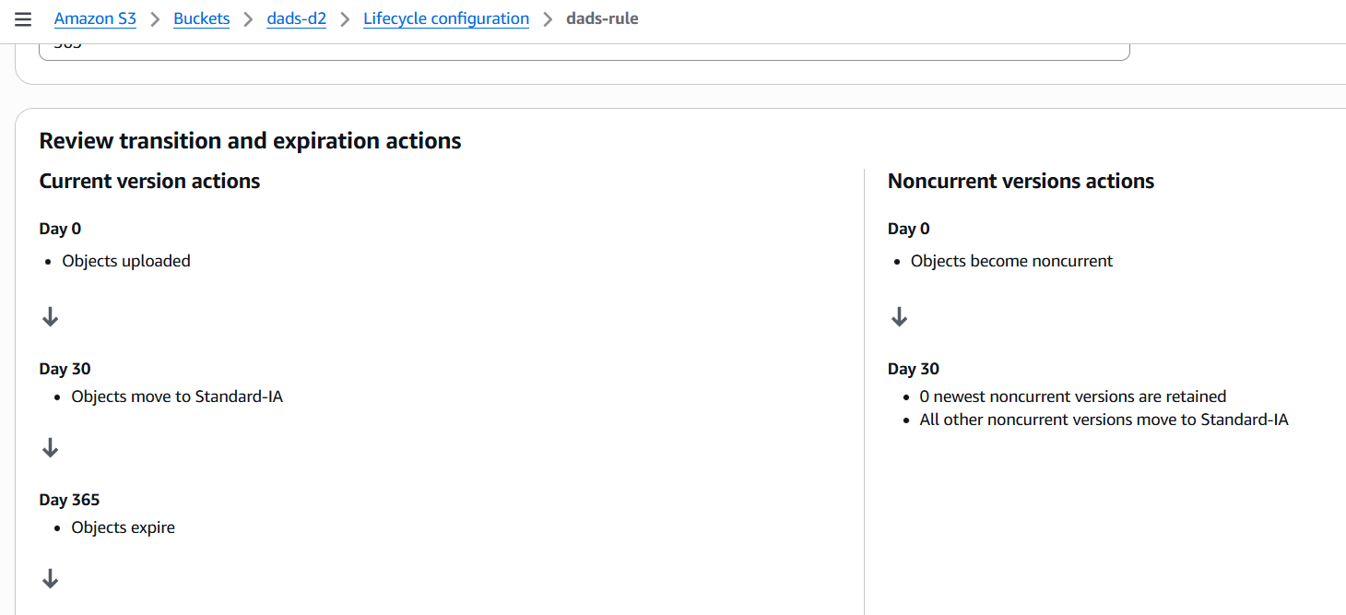
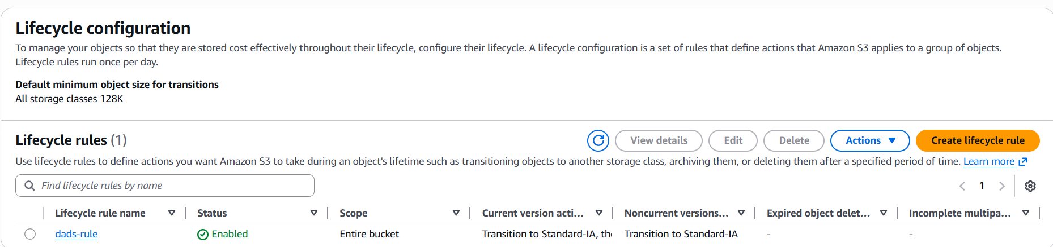
Push some objects to S3 using the AWS CLI.
Aws -–version
aws configure
(details )
aws s3 cp sample.txt s3://dads-d2/
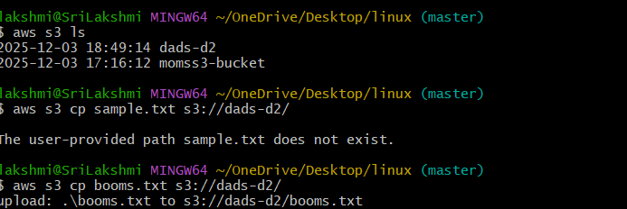

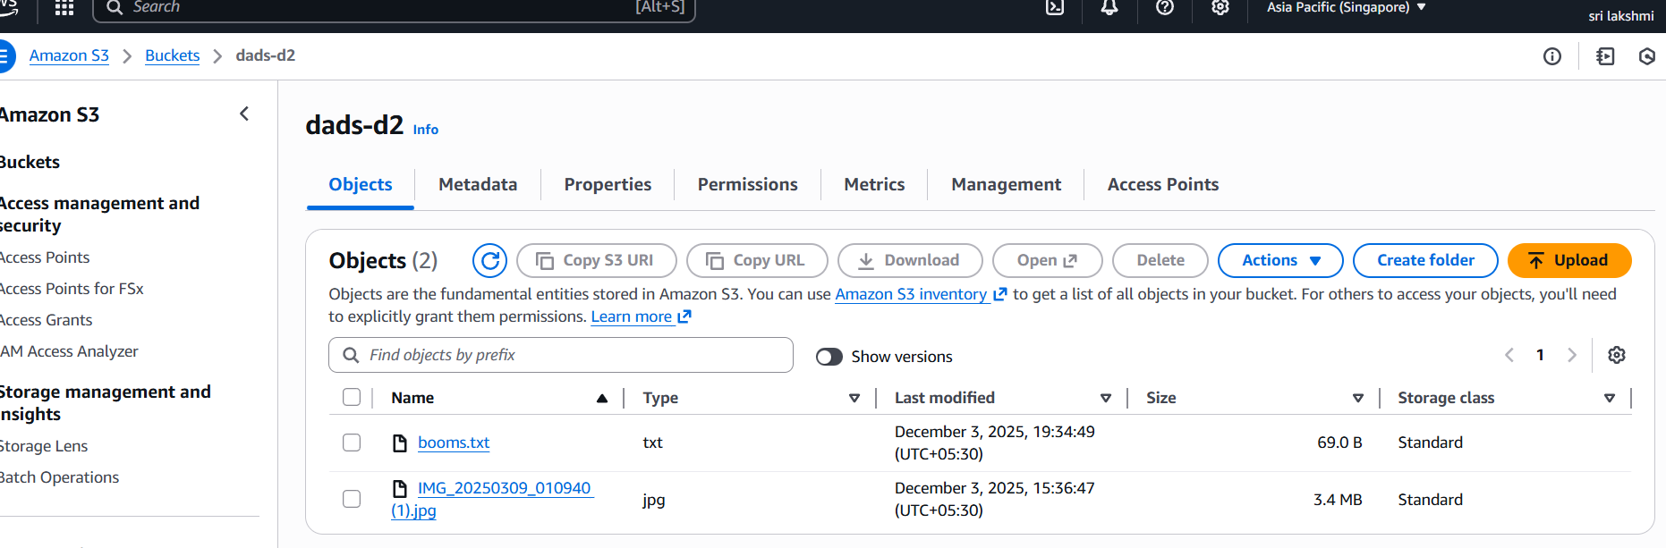
4.Write a Bash script to create an S3 bucket.
Aws –version
Aws configure
(details)
Aws s3 ls
Vi s3buk.bash
Chmod +x
./s3buk.bash

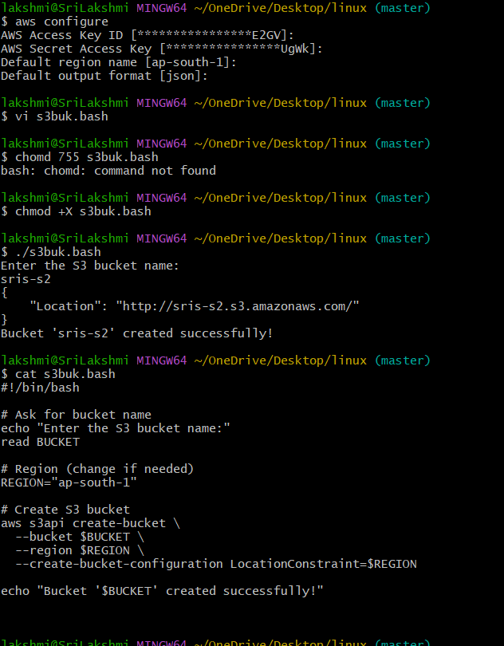

5.Upload a 1 GB file to S3 using the CLI.
Aws s3 ls
Pick 1gb files
Or create the bucket again
Uplodad again
creates the bucket
uploads the 1 GB file
verifies the upload
